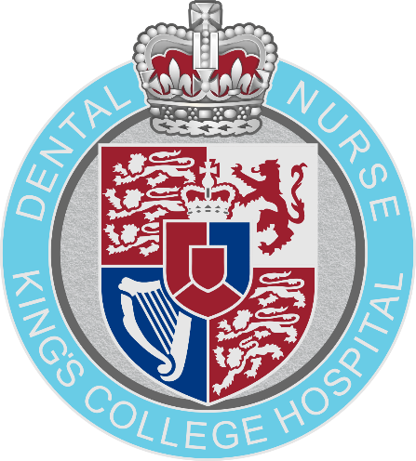

POST REGISTRATION COURSE
APPLICATION PACK
DENTAL SEDATION NURSING

CONTENTS

Important Information Pg. 3
Employer Information Sheet Pg. 4
Application Form Pg. 5
Course Suitability Checklist Pg. 7
Payment Information Pg. 8
Cancellation Policy Pg. 10
Extenuating Circumstances Form Pg. 11
Service Monitoring Agreement Pg. 12
Application Checklist Pg. 18

IMPORTANT INFORMATION

Entry Requirements
Any applicant for a Post Registration course must be registered with the General Dental Council.
They must also have access to the range of procedures required to complete their Record of Competence. More information regarding the procedures required for the course is available via the Employer Information Sheet (pg. 4)
Applicants will need to be self-motivated and will need to be supported in the workplace by suitably qualified staff willing to act as witnesses. More information about the role of the witness can be found on the Employer Information Sheet (pg. 4)

Course Attendance
Students are expected to attend a minimum of 90% of the face-to-face course dates provided. Students are also expected to review 100% of any learning material provided online. A full copy of the Attendance & Participation policy will be made available to students prior to the first date of the course for which they are applying.

Resit Policy
Candidates who fail the examination will continue to be supported by the DTEC team at no extra cost until the expiration of their Record of Competence. NEBDN however will charge a resit examination fee. Details of fees payable are available on the NEBDN website (www.nebdn.org). These fees are to be paid to DTEC in the first instance and are then forwarded to NEBDN.

Deferral Policy
Candidates who choose to / or are required to defer entry to the examination will continue to be supported by the DTEC team until the expiration of their Record of Competence. DTEC will however charge a fee (£350) where a candidate chooses to defer more than once or to an examination more than 6 months after the original examination date. NEBDN will charge a deferral fee for every deferral request. Details of fees payable are available on the NEBDN website (www.nebdn.org). These fees are to be paid to DTEC in the first instance and are then forwarded to NEBDN.

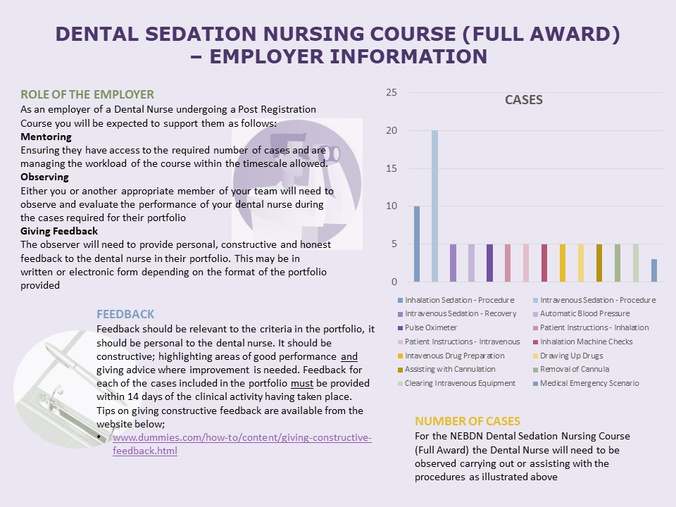
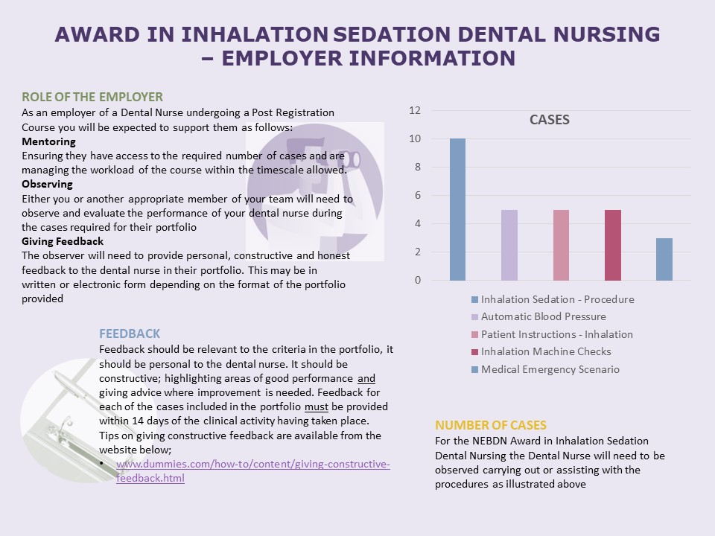
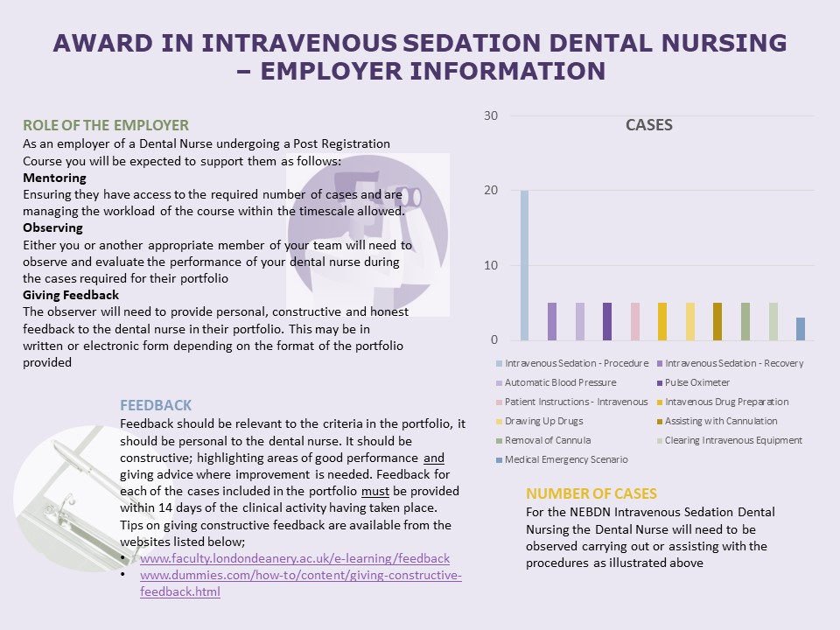
APPLICATION FORM
DENTAL TEAM EDUCATION CENTRE - COURSES
Please read and complete all sections of the application form. Incomplete applications will not be accepted by the centre and will be returned immediately to the sender.
Please indicate the course you are applying for:
Course name: | Tick here
DTEC Certificate in Clinical Photography
DTEC Certificate in Endodontic Nursing
DTEC Certificate in Fluoride Application
DTEC Certificate in Alginate Impression Taking
NEBDN Certificate in Dental Implant Nursing
NEBDN Certificate in Dental Radiography
NEBDN Certificate in Dental Sedation Nursing (Full Award)
NEBDN Certificate in Dental Sedation Nursing (Inhalation Sedation Only)
NEBDN Certificate in Dental Sedation Nursing (Intravenous Sedation Only)
NEBDN Certificate in Oral Health Education
NEBDN Certificate in Orthodontic Nursing
NEDBN Certificate in Special Care Dental Nursing (Blended Learning - Online)
Other: Please state course name here:

Personal Details:
Title: | First Name: | Last Name: |  | Date of Birth:
Home Address:

Home Postcode:
Photographic ID:
All applicants are required to submit a copy of valid Photographic ID with their Application Form. Acceptable forms of ID are listed below. Any ID provided must be in date i.e. have not expired. Please indicate which form of ID you are submitting with your application below.
ID Card / National Identification Card |  | ☐
Driving License |  | ☐
Passport |  | ☐
Work Address:

Work Postcode:
Home telephone: |  | Work telephone:
Mobile telephone:
Email Address:

GDC Registration Number: | Please state N/A if not applicable:
Evidence | All application forms must be accompanied with a copy of the below evidence.
Evidence | GDC registration certificate |  | Yes |  | No
Evidence | Dental Nursing certificate |  | Yes |  | No

Payment Agreement
Please enter full payment confirmation details for any online payments or PO details raised. Applications will not be accepted unless a valid PO number and or online payment authorisation number has been provided.
My employer is funding the course and I have been provided with a PO number | Yes | No
PO NUMBER:
I am funding the course and have paid online | Yes | No
ONLINE PAYMENT AUTHORISATION NUMBER:

To be completed by the Supervising Dentist/ Employer:
This form is to be signed off by your supervising dentist or Employer. As the supervising dentist or Employer you are confirming that all documentation has been completed in full by the applicant and is a true account.
As the supervising dentist/ Employer, I also agree to release the above candidate for all of the listed course dates and to supervise and validate all workplace activities to meet the course requirements.
Declaration:
Supervising Dentist / Employer - Name in full:

Signed: | Date:

THANK YOU FOR TAKING THE TIME TO COMPLETE - END OF APPLICATION.

COURSE SUITABLITY CHECKLIST
CERTIFICATE IN SEDATION DENTAL NURSING

Please read and complete all fields below:
Applicants Full Name
Applicants GDC Number

Study Leave has been arranged between myself and my employer | Yes | ☐ | No | ☐
Access to cases as listed below:
- Inhalation Sedation Procedure x 10 | Yes | ☐ | No | ☐
- Intravenous Sedation Recovery x 5 | Yes | ☐ | No | ☐
- Intravenous Sedation Procedure x 20 | Yes | ☐ | No | ☐
- Automatic Blood Pressure x 5 | Yes | ☐ | No | ☐
- Pulse Oximeter x 5 | Yes | ☐ | No | ☐
- Patient Instructions x 5 | Yes | ☐ | No | ☐
- Inhalation Machine Checks x 5 | Yes | ☐ | No | ☐
- Intravenous Drug Preparation x 5 | Yes | ☐ | No | ☐
- Drawing Up Drugs x 5 | Yes | ☐ | No | ☐
- Assisting with Cannulation x 5 | Yes | ☐ | No | ☐
- Removal of Cannula x 5 | Yes | ☐ | No | ☐
- Clearing IV Equipment x 5 | Yes | ☐ | No | ☐
- Medical Emergencies Simulation x 3 | Yes | ☐ | No | ☐
Access to the support of at least one GDC registered clinician to act as a witness during the completion of your Record of Competence | Yes | ☐ | No | ☐

I confirm that the above information is accurate
Employer Name:
Employer GDC Number:
Employer Signature:
Date:

Incomplete checklists will not be accepted by the centre and will be returned immediately to the sender.

We welcome feedback on how you heard about the course. Please click here to complete the form.
MAKING A PAYMENT

Methods of Payment
Option 1 – Telephone Payment
To make a telephone payment please call 0203 299 6428. It is important to quote your full name, the amount you are paying and the course you will be attending, together with the following information:
Cost Code: 303279
Subjective Code: 455800
Option 2 – Credit Card Payment
If you prefer you can make a Credit Card payment, by completing the attached form, ensuring you complete all details in full to include the course name you wish to attend.
Please note that we do not accept card payments made by American Express.
Option 3 – Bank Transfer
If you prefer to make a bank transfer – details needed are below:
Account Name: GBS RE KINGS COLL HOSP NHSFT
Account Number: 10020217
Bank Sort Code: 60-70-80
It is very important and essential that you ensure a reference is added – this should be your Initial, Surname, Course Name and reference number 303279-455800
IMPORTANT
Once you have processed your payment, please can you email me maxine.pawsey@nhs.net and let me know what payment option you chose and the amount you paid.

Course:
Date:
Credit card details below:

Details for credit card payments
NAME ON CARD:
CARD NUMBER:
EXPIRY DATE:
(Month/Year)
CV2*
CUSTOMER PHONE NUMBER:
CUSTOMER EMAIL:
BILLING ADDRESS:
CITY:
COUNTY/STATE:
POSTCODE/ZIP:
COUNTRY:
AMOUNT: | £
REFERENCE CODE: | 303279
SUBJECTIVE CODE: | 455800
I CONSENT TO PAYMENT OF £ TO BE CHARGED TO THE ACCOUNT LISTED ABOVE: | Yes ☐ No ☐

Please send completed form to Amanda White, Head of Financial Transactions (amanda.white1@nhs.net) or Josephine Olukoya (josephine.olukoya@nhs.net).
A copy should also be sent to maxine.pawsey@nhs.net

BOOKING, CANCELLATION AND REFUND POLICY

Seminar and Course Bookings
To help maintain the quality of course delivery, all our course and seminars are subject to a limit on the
maximum number of delegates. Once a course is full any additional applicants will be offered a place on
the waiting list. This will mean your application is held until the next intake. If, for any reason, a place
becomes available on the current course you may be contacted and offered an earlier opportunity to join
the course.
Having completed the relevant application form and submitted full payment you will be sent a letter of
confirmation. You do not have a place on the course until the letter of confirmation has been sent.

Cancellations by the Applicant
By completing your application for a course and making a payment (whether in full or in instalments), you
agree to the following Terms and Conditions. We acknowledge that sometimes there is a need to cancel
your enrolment from a course/training workshop. If you cannot attend, or no longer require a place, please
provide notice of cancellation at least 6 weeks prior to the start of the course.

Cancellations received 6 weeks or more prior to the course/seminar start date will be refunded the fee you
have paid less an administration fee of £50.

Cancellations received less than 6 weeks prior to the course/seminar start date will not be eligible for a
refund.

Refunds may, however, be considered where there are extenuating circumstances. If you consider your
cancellation to be due to extenuating circumstances please complete the Extenuating Circumstances form
and submit by email to maxine.price1@nhs.net. Where cancellations due to extenuating circumstances are
accepted a full refund, minus a £50 administration fee, will be made.

Cancellations by the Centre
All bookings are accepted on the understanding that a course or seminar will only be delivered if it attracts
the required minimum number of delegates to ensure viability. In the unlikely event that a course is
cancelled by the Centre we will notify you at least 2 weeks before the date of the course or seminar (as far
as is reasonably practicable) and we will refund all fees paid. All refunds will be paid as soon as possible
after the date of cancellation.
EXTENUATING CIRCUMSTANCES REFUND REQUEST FORM

By completing your application for a course and making a payment (whether in full or in instalments), you agree to the following Terms and Conditions.

We acknowledge that sometimes there is a need to cancel your enrolment from a course/training workshop. If you cannot attend, or no longer require a place, please provide notices of cancellation at least 6 weeks prior to the start of the course.
- Cancellations received 6 weeks or more prior to the course/seminar start date will be refunded the fee you have paid less an administration fee of £50.
- Cancellations received less than 6 weeks prior to the course/seminar start date will not be eligible for a refund.
- Refunds may, however, be considered where there are extenuating circumstances (global pandemic or where clinical activity is greatly reduced at point of application) may be considered. If you consider your cancellation to be due to extenuating circumstances, please complete this form and submit by email to maxine.price1@nhs.net. Where cancellations due to extenuating circumstances are accepted a full refund, minus a £50 administration fee, will be made.

Refunds will be made to Payee only.

To be completed by applicant:

Name |  | Date of Request
Course |  | Fees Paid
Reason for Refund
Address for Refund
Signature

For Office Use Only:

Date of Cancellation |  | Date of action
Total Amount of Refund |  | Actioned by
Notes:



Service and Monitoring Agreement
Purpose
The purpose of the Service and Monitoring Agreement (SMA) is to formalise the roles and responsibilities of all parties involved in the delivery of training and assessment for Dental Nurses working towards the post registration qualifications; Employer, Centre and NEBDN and to ensure that Learners have continued access to a suitable clinical learning environment. It is the Centre’s responsibility to ensure effective provision of clinical training is provided by Employers/Clinical Placements.

This SMA sets out the guiding principles necessary for the establishment of an effective training and working environment consistent with health and safety legislation, NEBDN mandated documentation and current GDC guidelines.
Process
- The SMA must be completed prior to the Centre accepting a Learner onto the training course. Failure of any party to complete and sign the SMA may result in the Learner not being accepted onto the post registration qualification

- Evidence must be seen of the Learner’s Dental Nurse Qualification certificate and current GDC registration certificate

- Photographic ID checks must be completed prior to accepting a Learner onto the training course (e.g. passport, photographic driving licence (including provisional licence), Citizen card, Workplace issued identity card)

- If more than one Learner from a practice is undertaking training with the same Centre, one form must be completed for each Learner

- As part of the process, Centres must ensure that they check there are sufficient witnesses to support a Learner to complete each element of the Record of Competence (RoC)

- It is the Centre’s responsibility to ensure that witnesses have the appropriate skills, knowledge and training to support the Learner, and that professional registration is checked, validated and recorded by the Learner within the Witness Status List located within the RoC

- Guidance and training tools to support Centres and Witnesses is found at Witness-Toolkit-v1.0-PDF-2021.pdf (nebdn.org)

- The Centre and Employer must keep a copy of the completed SMA for their own records. These will be reviewed for each Learner as part of NEBDN’s Quality Audit process and could be requested by NEBDN at any point.

Names of Learners covered under this Agreement:

Name | Employment Status (employed full time, employed part time, full time student)
Services and Requirements to be provided under this agreement by:
Employer
………………………………………. (Insert Employer/ placement name) is/are committed to providing continual support to the Learner whilst training towards the NEBDN post-registration qualification provided by the Centre and will commit to the following:

- The Employer and/or witness(es) must attend the Centre induction at the beginning of the programme, which will explain the course content, assessment methods and Record of Competence requirements

- Allow the Learner to attend training according to the pre-notified timetable

- Ensure that all Witnesses are registered healthcare professionals with the appropriate qualification in the relevant subject matter and can commit the time needed to support the learner appropriately by observing practice and performance, providing constructive feedback, both verbally and within the witness asset, accordingly. Consideration must be given if the registrant has any conditions in place i.e., would the learner be at risk.

- Ensure that the Learner will receive appropriate workplace training and supervision

- Employers must ensure that quarterly progress reports are compiled and shared with the Centre and Learner which include attendance, development of clinical skills, professionalism, clinical decision making, attitude, communication skills with the dental team and the patients, team working and identification of any concerns or risks that may affect the Learner’s ability to complete the qualification, as a minimum

- Ensure all witness assets are signed, ideally at the time of completion, or within 14 days of the date of activity otherwise the asset will be deemed invalid

- Ensure that all patients are made aware that they are being treated by Learners and give consent:
  - Patients must be provided with information about the Learner’s and Supervisor’s roles, what standards they can expect from Learner dental nurse, what they should do if they wish to provide feedback
  - Ensure that there is a suitable method to clearly identify the Learner to patients and other Dental Care Professionals within the clinical environment
  - Inform the Centre of any Learner Fitness to Practise/Fitness to Practise issues.
The requirements for the Learner to complete the RoC are as follows:

Sedation Dental Nursing

Black sections – to be completed all candidates | White sections – to be completed by Inhalation Sedation candidates | Grey sections – to be completed by Intravenous Sedation candidates

Practical Competence Assessment Sheets | 10 of:  Inhalation Sedation
Practical Competence Assessment Sheets | 20 of:  Intravenous Sedation - procedure
Practical Competence Assessment Sheets | 5 of:  Intravenous Sedation – Recovery
Case Studies | 1 required of:  Inhalation Sedation Procedure
Case Studies | 1 required of:  Intravenous Sedation
Directly Observed Clinical Skills Assessment | 5 of each:
Directly Observed Clinical Skills Assessment | Automatic blood Pressure
Directly Observed Clinical Skills Assessment | Pulse Oximeter
Directly Observed Clinical Skills Assessment | Patient Instructions – IH Sedation
Directly Observed Clinical Skills Assessment | Patient Instructions – IV Sedation
Directly Observed Clinical Skills Assessment | IH Sedation – machine checks
Directly Observed Clinical Skills Assessment | Prepare IV equipment
Directly Observed Clinical Skills Assessment | Drawing up Drugs
Directly Observed Clinical Skills Assessment | Assist during cannulation
Directly Observed Clinical Skills Assessment | Removal of cannula
Directly Observed Clinical Skills Assessment | Clear IV equipment
Directly Observed Clinical Skills Assessment | IH machine shutdown and clean
Directly Observed Clinical Skills Assessment | Medical emergency scenario (3 required)
Supplementary Outcomes | - Life Support Skills certificate(s)  - List of equipment  - List of emergency drugs  - National guidance  - Ethical dilemma  - Audit and Patient satisfaction  - Advantages and Disadvantages  - Anxiety management options  - Reflective practice  - CPD record and Personal Development Plan

By signing this SMA you are permitting the Centre to monitor the Employer/clinical placement induction to ensure Learners have access to a suitable clinical learning environment for the respective qualification, and that all requirements detailed above will be met.

Employer Details:
Practice Address:

Type of Practice e.g. GDP, Private, Hospital or Specialist (please give details):

Named Contact:
Named Contact phone number:
Learner Mentor name:
Learner Mentor GDC No:
Witness(es) Name(s):
Witness(es) GDC Registration Number(s):

Employer name:
Employer GDC Registration No.:
Employer Email address:
Signed:
Date:

Centre
All Centres are required to go through an approval process with the NEBDN to ensure their qualification delivery meets the NEBDN Standards for Accreditation. Centres must ensure all Employers and Learners are made aware of the qualification requirements, and that if full accreditation status is not met, Learners will be unable to sit the final examination.
………………………………………. (Insert Centre name) is committed to providing education, training and support to the Learner for as long as training towards the post-registration course is being provided on behalf of the Employer and will ensure compliance with the NEBDN Standards for Accreditation.
It is the Centre’s responsibility to ensure that information relating to all witnesses must be documented, verified and monitored by the Centre.
The Centre must validate each witness email address to ensure authenticity.
The Internal Verifier must check each Witness against the relevant register and confirm that they are current registrants, at each verification session, in accordance with the NEBDN Toolkit to Support Centres with the RoE/RoC.
As part of the final process for the RoC sign off, the Internal Verifier must complete the checks on the RoE to ensure that it has satisfactorily met all NEBDN requirements and record this check on the Witness Status List.
All witnesses must be made aware that their registration is at risk if they knowingly make false declarations within the RoC.
Centres must ensure that quarterly progress reports are compiled and shared with the Employer and Learner. The report must include detail on attendance, theoretical progress, assessment results, attitude, communication skills, identification of any concerns or risks that may affect the Learner’s ability to complete the qualification and RoC progress, as a minimum.
Centre Named representative:
Centre Name:
Centre Address:

Centre Contact Telephone Number:
Centre Email Address:
Date of when Employer/Clinical Placement Induction documentation seen:
Date of when Proposed Witness(es) checks completed by Centre:
Signed:
Date:

Centre Risk Monitoring:
A named person within the Centre must complete a check of the most recent CQC inspection and highlight any concerns below before enrolling the Learner onto the course.
CQC certificate number and date of verification:
Any risk (s) identified: | Yes £ | No £
If yes, please give details:

Actions Agreed, including timescales:

Name of the Centre Representative completing these checks:
GDC Registration No:
Date completed:

Signature:

General Terms and Conditions:
Centre
Should any issue arise in relation to the quality, amount and type of support being offered by the Employer, attempts should be made to resolve them directly with the Employer. If there is no resolution, or if the Centre has serious concerns and/or a risk has been identified, NEBDN must be informed.

Employer
Should any issue arise regarding the quality of the education being offered by the Centre, attempts should be made to resolve them directly with the Centre in the first instance, following the Centre’s documented complaints procedure. Only then if the issue is not resolved can the employer contact NEBDN.

APPLICATION CHECKLIST

Before submitting your application documentation, please check you have completed and included the following:

Application Form | ☐
Course Suitability Form | ☐
GDC Registration Document | ☐
Dental Nursing Qualification Certificate | ☐
One form of ID | ☐
Service Monitoring Agreement | ☐

