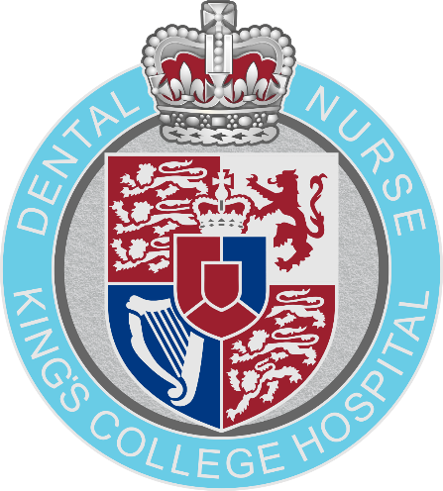

POST REGISTRATION COURSE
APPLICATION PACK
FLUORIDE APPLICATION

CONTENTS

Important Information Pg. 3
Employer Information Sheet Pg. 4
Application Form Pg. 5
Course Suitability Checklist Pg. 7
Payment Information Pg. 8
Cancellation Policy Pg. 10
Extenuating Circumstances Form Pg. 11
Application Checklist Pg. 12

IMPORTANT INFORMATION

Entry Requirements
Any applicant for a Post Registration course must be registered with the General Dental Council.
They must also have access to the range of procedures required to complete their Portfolio of Evidence. More information regarding the procedures required for the course is available via the Employer Information Sheet (pg. 4)
Applicants will need to be self-motivated and will need to be supported in the workplace by suitably qualified staff willing to act as witnesses. More information about the role of the witness can be found on the Employer Information Sheet (pg. 4)

Course Attendance
Students are expected to attend a minimum of 90% of the face-to-face course dates provided. Students are also expected to review 100% of any learning material provided online. A full copy of the Attendance & Participation policy will be made available to students prior to the first date of the course for which they are applying.

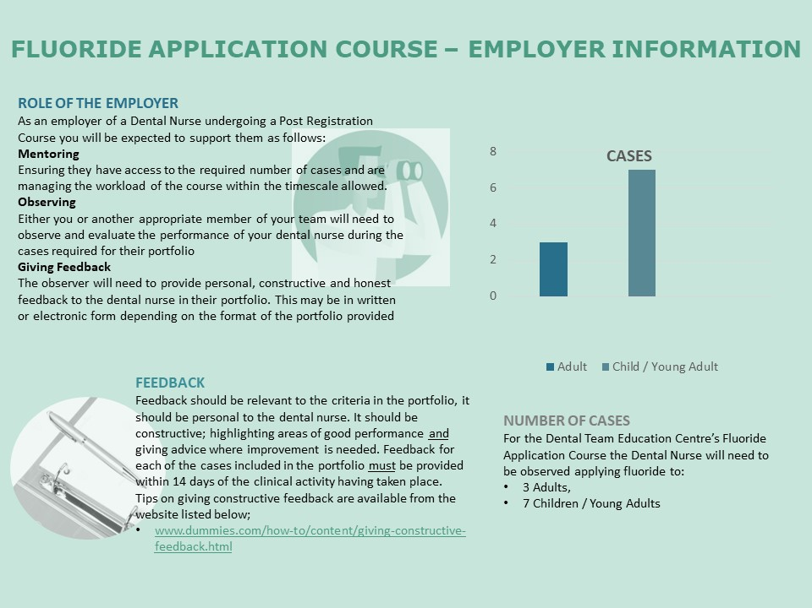

APPLICATION FORM
DENTAL TEAM EDUCATION CENTRE - COURSES
Please read and complete all sections of the application form. Incomplete applications will not be accepted by the centre and will be returned immediately to the sender.
Please indicate the course you are applying for:
Course name: | Tick here
DTEC Certificate in Clinical Photography
DTEC Certificate in Endodontic Nursing
DTEC Certificate in Fluoride Application
DTEC Certificate in Alginate Impression Taking
NEBDN Certificate in Dental Implant Nursing
NEBDN Certificate in Dental Radiography
NEBDN Certificate in Dental Sedation Nursing (Full Award)
NEBDN Certificate in Dental Sedation Nursing (Inhalation Sedation Only)
NEBDN Certificate in Dental Sedation Nursing (Intravenous Sedation Only)
NEBDN Certificate in Oral Health Education
NEBDN Certificate in Orthodontic Nursing
NEDBN Certificate in Special Care Dental Nursing (Blended Learning - Online)
Other: Please state course name here:

Personal Details:
Title: | First Name: | Last Name: |  | Date of Birth:
Home Address:

Home Postcode:
Photographic ID:
All applicants are required to submit a copy of valid Photographic ID with their Application Form. Acceptable forms of ID are listed below. Any ID provided must be in date i.e. have not expired. Please indicate which form of ID you are submitting with your application below.
ID Card / National Identification Card |  | ☐
Driving License |  | ☐
Passport |  | ☐
Work Address:

Work Postcode:
Home telephone: |  | Work telephone:
Mobile telephone:
Email Address:

GDC Registration Number: | Please state N/A if not applicable:
Evidence | All application forms must be accompanied with a copy of the below evidence.
Evidence | GDC registration certificate |  | Yes |  | No
Evidence | Dental Nursing certificate |  | Yes |  | No

Payment Agreement
Please enter full payment confirmation details for any online payments or PO details raised. Applications will not be accepted unless a valid PO number and or online payment authorisation number has been provided.
My employer is funding the course and I have been provided with a PO number | Yes | No
PO NUMBER:
I am funding the course and have paid online | Yes | No
ONLINE PAYMENT AUTHORISATION NUMBER:

To be completed by the Supervising Dentist/ Employer:
This form is to be signed off by your supervising dentist or Employer. As the supervising dentist or Employer you are confirming that all documentation has been completed in full by the applicant and is a true account.
As the supervising dentist/ Employer, I also agree to release the above candidate for all of the listed course dates and to supervise and validate all workplace activities to meet the course requirements.
Declaration:
Supervising Dentist / Employer - Name in full:

Signed: | Date:

THANK YOU FOR TAKING THE TIME TO COMPLETE - END OF APPLICATION.

COURSE SUITABLITY CHECKLIST
CERTIFICATE IN FLUORIDE APPLICATION

Please read and complete all fields below:
Applicants Full Name
Applicants GDC Number

Study Leave has been arranged between myself and my employer | Yes | ☐ | No | ☐
Access to cases as listed below:
- Children / Young Adults x 7 | Yes | ☐ | No | ☐
- Adults x 3 | Yes | ☐ | No | ☐
Access to the support of at least one GDC registered clinician to act as a witness during the completion of your Record of Competence | Yes | ☐ | No | ☐

I confirm that the above information is accurate
Employer Name:
Employer GDC Number:
Employer Signature:
Date:

Incomplete checklists will not be accepted by the centre and will be returned immediately to the sender.

We welcome feedback on how you heard about the course. Please click here to complete the form.

MAKING A PAYMENT

Methods of Payment
Option 1 – Telephone Payment
To make a telephone payment please call 0203 299 6428. It is important to quote your full name, the amount you are paying and the course you will be attending, together with the following information:
Cost Code: 303279
Subjective Code: 455800
Option 2 – Credit Card Payment
If you prefer you can make a Credit Card payment, by completing the attached form, ensuring you complete all details in full to include the course name you wish to attend.
Please note that we do not accept card payments made by American Express.
Option 3 – Bank Transfer
If you prefer to make a bank transfer – details needed are below:
Account Name: GBS RE KINGS COLL HOSP NHSFT
Account Number: 10020217
Bank Sort Code: 60-70-80
It is very important and essential that you ensure a reference is added – this should be your Initial, Surname, Course Name and reference number 303279-455800
IMPORTANT
Once you have processed your payment, please can you email me maxine.pawsey@nhs.net and let me know what payment option you chose and the amount you paid.

Course:
Date:
Credit card details below:

Details for credit card payments
NAME ON CARD:
CARD NUMBER:
EXPIRY DATE:
(Month/Year)
CV2*
CUSTOMER PHONE NUMBER:
CUSTOMER EMAIL:
BILLING ADDRESS:
CITY:
COUNTY/STATE:
POSTCODE/ZIP:
COUNTRY:
AMOUNT: | £
REFERENCE CODE: | 303279
SUBJECTIVE CODE: | 455800
I CONSENT TO PAYMENT OF £ TO BE CHARGED TO THE ACCOUNT LISTED ABOVE: | Yes ☐ No ☐

Please send completed form to Amanda White, Head of Financial Transactions (amanda.white1@nhs.net) or Josephine Olukoya (josephine.olukoya@nhs.net).
A copy should also be sent to maxine.pawsey@nhs.net

BOOKING, CANCELLATION AND REFUND POLICY

Seminar and Course Bookings
To help maintain the quality of course delivery, all our course and seminars are subject to a limit on the
maximum number of delegates. Once a course is full any additional applicants will be offered a place on
the waiting list. This will mean your application is held until the next intake. If, for any reason, a place
becomes available on the current course you may be contacted and offered an earlier opportunity to join
the course.
Having completed the relevant application form and submitted full payment you will be sent a letter of
confirmation. You do not have a place on the course until the letter of confirmation has been sent.

Cancellations by the Applicant
By completing your application for a course and making a payment (whether in full or in instalments), you
agree to the following Terms and Conditions. We acknowledge that sometimes there is a need to cancel
your enrolment from a course/training workshop. If you cannot attend, or no longer require a place, please
provide notice of cancellation at least 6 weeks prior to the start of the course.

Cancellations received 6 weeks or more prior to the course/seminar start date will be refunded the fee you
have paid less an administration fee of £50.

Cancellations received less than 6 weeks prior to the course/seminar start date will not be eligible for a
refund.

Refunds may, however, be considered where there are extenuating circumstances. If you consider your
cancellation to be due to extenuating circumstances please complete the Extenuating Circumstances form
and submit by email to maxine.price1@nhs.net. Where cancellations due to extenuating circumstances are
accepted a full refund, minus a £50 administration fee, will be made.

Cancellations by the Centre
All bookings are accepted on the understanding that a course or seminar will only be delivered if it attracts
the required minimum number of delegates to ensure viability. In the unlikely event that a course is
cancelled by the Centre we will notify you at least 2 weeks before the date of the course or seminar (as far
as is reasonably practicable) and we will refund all fees paid. All refunds will be paid as soon as possible
after the date of cancellation.
EXTENUATING CIRCUMSTANCES REFUND REQUEST FORM

By completing your application for a course and making a payment (whether in full or in instalments), you agree to the following Terms and Conditions.

We acknowledge that sometimes there is a need to cancel your enrolment from a course/training workshop. If you cannot attend, or no longer require a place, please provide notices of cancellation at least 6 weeks prior to the start of the course.
- Cancellations received 6 weeks or more prior to the course/seminar start date will be refunded the fee you have paid less an administration fee of £50.
- Cancellations received less than 6 weeks prior to the course/seminar start date will not be eligible for a refund.
- Refunds may, however, be considered where there are extenuating circumstances (global pandemic or where clinical activity is greatly reduced at point of application) may be considered. If you consider your cancellation to be due to extenuating circumstances please complete this form and submit by email to maxine.price1@nhs.net. Where cancellations due to extenuating circumstances are accepted a full refund, minus a £50 administration fee, will be made.

Refunds will be made to Payee only.

To be completed by applicant:

Name |  | Date of Request
Course |  | Fees Paid
Reason for Refund
Address for Refund
Signature

For Office Use Only:

Date of Cancellation |  | Date of action
Total Amount of Refund |  | Actioned by
Notes:

APPLICATION CHECKLIST

Before submitting your application documentation, please check you have completed and included the following:

Application Form | ☐
Course Suitability Form | ☐
GDC Registration Document | ☐
Dental Nursing Qualification Certificate | ☐
One form of ID | ☐

