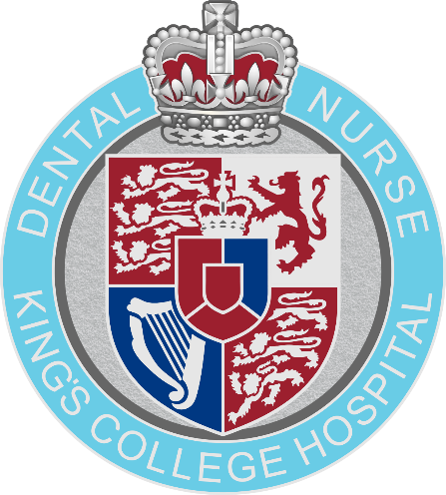

APPLICATION PACK
NEBDN LEVEL 3 DIPLOMA IN DENTAL NURSING (RQF)

CONTENTS

Important Information Pg. 3
Employer Information Sheet Pg. 4
Application Form Pg. 5
Equal Opportunities Monitoring Pg. 8
Course Suitability Checklist Pg. 9
Payment Information Pg. 11
Cancellation Policy Pg. 12
Extenuating Circumstances Form Pg. 13
Service Monitoring Agreement Pg. 14
Learner Workplace Induction Checklist Pg. 34
Employer and GDC Supervising Registrant Declaration Pg. 37
Appendix A: Template: Waiting Room Patient Notice Pg. 38
Application Checklist Pg. 39

IMPORTANT INFORMATION

Entry Requirements
Any applicant for the NEBDN Level 3 National Diploma in Dental Nursing (RQF) course must be employed as a Trainee Dental Nurse prior to application and aged 16 years and over. Applicant must be sufficiently fluent in written and spoken English for effective communication with patients, their relatives, the dental team and other healthcare professionals.
Applicants must be able to meet the work-based clinical requirements of the Portfolio of Evidence (PoE) see application checklist. More information regarding the procedures required for the course is available via the Employer Information Sheet (pg. 4)
Applicants will need access to a computer or laptop to access all IT software for the Portfolio of Evidence and all Online Assessments. All guidance on what IT can be used for this qualification can be found on the NEBDN website (Click this link) NEBDN Resources - for Hardware Guidelines and Computer health check.
Applicants need to be self-motivated and will need to be supported in the workplace by suitably qualified staff willing to act as a their Named GDC Supervising Registrant (Workplace Mentor) and / or Witnesses. More information about the role of the witness can be found on the Employer Information Sheet (pg. 4)
Course Attendance
Students are expected to attend all the face-to-face course dates provided. Students are also expected to review 100% of any learning material provided online. A full copy of the Attendance & Participation policy will be made available to students prior to the first date of the course for which they are applying.
Resit Policy
Candidates who fail the examination will continue to be supported by the DTEC team at no extra cost. The NEBDN allow 3 resits for each of the Knowledge and Professional Discussion exams, if the candidate fails the resits, they will have to start the course again. NEBDN however will charge a resit examination fee. Details of fees payable are available on the NEBDN website (www.nebdn.org). These fees are to be paid to DTEC in the first instance and are then forwarded to NEBDN.

Deferral Policy
Candidates who choose to / or are required to defer entry to the examination will continue to be supported by the DTEC team. DTEC will however charge a fee (£350) where a candidate chooses to defer more than once or to an examination more than 6 months after the original examination date. NEBDN will allow one deferral, any other deferrals will be counted as a resit.
NEBDN will charge a deferral fee for every deferral request. Details of fees payable are available on the NEBDN website (www.nebdn.org). These fees are to be paid to DTEC in the first instance and are then forwarded to NEBDN.

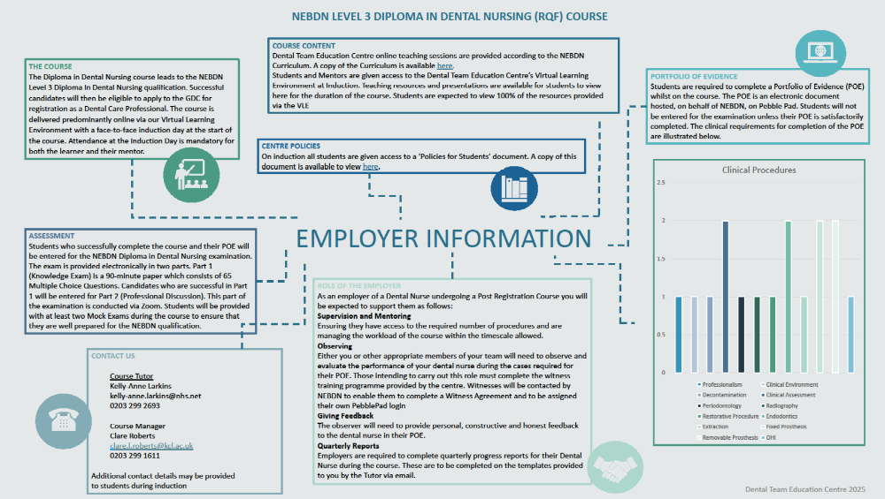
APPLICATION FORM
ONLINE DENTAL NURSE COURSE
APPLICATION FORM

Personal Details
Title (Mr/Ms/Miss/Mrs etc): |  | First Name: |  | Last Name: |  |  |  |  | Date of Birth:
Address (Home): |  | Postcode:
Address (Work): |  | Practice Name:  Address:  Postcode:
Telephone (H):
Telephone (W):
Telephone (M):
Email Address:
Photographic ID:
All applicants are required to submit a copy of valid Photographic ID with their Application Form. Acceptable forms of ID are listed below. Any ID provided must be in date i.e. have not expired. Please indicate which form of ID you are submitting with your application below.
ID Card / National Identification Card |  |  |  | ☐
Driving Licence (Copy of Front and Back of Licence to be provided) |  |  |  | ☐
Passport (the copy Must display both pages, including the observation and holder’s signature section) |  |  |  | ☐
Right To Work (non-UK resident):
Do you have the right to work in the UK and can provide valid documentation? Please tick the box, if applicable, and provide the relevant documentation with your application. |  |  |  | ☐
Employment History
Current Employment:
Employer Name: |  |  |  |  | Start date of employment
Employed Full or Part time |  |  |  |  | Working Hours per week
Role Description: |  | Title:  Description:
Previous Employment: |  |  | Dates: |  |  | From: (Month/Year) |  |  |  | To: (Month/Year)
Employer Details: |  |  | Date:
Employer Details: |  |  | Date:
Employer Details: |  |  | Date:
Educational Background
Learning Establishment Last Attended: |  |  | Name:  Address:
Dates Attended: |  |  | From: (Month/Year) To: (Month/Year)
Course/Qualification:
Courses Attended (last three years): |  |  | Dates: |  |  | From: (Month/Year) |  |  |  | To: (Month/Year)
 |  |  | Date:
 |  |  | Date:
 |  |  | Date:
 |  |  | Date:
 |  |  | Date
Learning Needs:
Please answer the following questions relating to your learning needs.
My computer skills are: |  | Non-Existent | ☐ |  |  | Adequate |  |  |  | ☐
 |  | Good | ☐ |  |  | Excellent |  |  |  | ☐
This qualification is delivered and assessed in English. You must be sufficiently fluent in written and spoken English to communicate effectively with patient, their relatives, the dental team, and other healthcare professionals (GDC Standards for the Dental Team, 2:1.2).
English is my: |  | First Language | ☐ |  |  | Second Language |  |  |  | ☐
Evidence of English Qualification held equivalent to GCSE English Language Grade C/4-5 or IELTS Type - Academic (overall average = 7) |  | Yes: | ☐ |  |  | No: |  |  |  | ☐
 |  | Qualification held:
Please provide a copy of your English Language Qualification Certificate (GCSE, IELTS or equivalent) with this application. Failure to provide proof of qualification, may result in an English assessment to be completed prior to being offered a place onto the course. If the English assessment results indicate a score below the level of English skills required, an appropriate English course such as the Level 2 Functional Skills in English qualification or equivalent, will need to be passed, prior to enrollment on the course.
Health Issues or Disabilities:
KCH and DTEC welcomes applications from people with special needs and considers them on the same academic grounds as those from other candidates. It is helpful to know about your special needs in advance so that we can discuss whether facilities are available. If you have special needs, please tick the boxes and add any further information that we can use to offer support.
 |  | Yes: | No: |  | Please specify:
Specific learning needs related to language and literacy? |  | ☐ | ☐
Dyslexia |  | ☐ | ☐
Blind/partially sighted |  | ☐ | ☐
Deaf/hearing impaired |  | ☐ | ☐
Other special needs |  | ☐ | ☐
Need Personal Care Support |  | ☐ | ☐
Mental Health Difficulties |  | ☐ | ☐
Wheelchair user/mobility difficulties |  | ☐ | ☐
An unseen special need e.g., Diabetes, epilepsy, asthma, any other medical conditions. |  | ☐ | ☐
Are you a registered disabled person? |  | ☐ | ☐
Vaccinations:
Are all your required routine vaccinations up to date (including Hepatitis B)? |  | Yes:  ☐ | No:  ☐ |  |  | Please specify:
Criminal Convictions:
Do you have any criminal convictions or cautions? |  | Yes:  ☐ | No:  ☐ |  |  | Please specify:
Names GDC Supervising Registrant (Mentor) Information
For the purposes of this course, you will need to have been allocated a named GDC Supervising Registrant whose role is to support your learning and observe your performance in the workplace. Please give their details below:
Name:
GDC Registration No:
Telephone (H):
Telephone (W):
Telephone (M):
Email Address:
Payment Information
My employer is funding the course, and I have been provided with a PO number |  |  |  |  |  |  |  | Yes |  | ☐ | No | ☐
PO Number:
I am funding the course and have paid via: |  |  | Bank transfer |  |  |  | ☐
 |  |  | Card payment |  |  |  | ☐
Payment Reference number:

EQUAL OPPORTUNITIES MONITORING:
Please help us to ensure our equal opportunities policy is applied effectively by placing a tick in the relevant boxes below
Asian or Asian British
Indian | ☐ | Pakistani |  | ☐ |  | Bangladeshi | ☐
Chinese | ☐ | Other Asian background |  | ☐
Black or Black British
Caribbean | ☐ | African |  | ☐ |  | Other black background | ☐
Mixed Race
White and black Caribbean | ☐ | White and Asian |  | ☐ |  | Other mixed background | ☐
White and black African | ☐
White
British | ☐ | Irish |  | ☐ |  | Other white background | ☐
Other
Other Ethnic Background | ☐ |  | Please state:

COURSE SUITABLITY CHECKLIST
NEBDN ONLINE DIPLOMA IN DENTAL NURSING
Please read and complete all sections of the checklist. By indicating ‘Yes’ to the answers in the checklist, you are agreeing to the Terms and Conditions of the course:
Applicant Full Name:
Applicant Signature:
Named GDC Supervising Registrant Full Name:
(Mentor and Dental Care Professional)
Mentor Signature:
Mentor GDC Number:
Date:

Requirements | Yes | No
Applicant employment date and start date of the course are no longer than one year in duration – if ‘No’ please add explanation in the comments box below.
Applicant is employed Full or Part time (minimum 16 hours)
Applicant has received a full workplace induction and Named GDC Supervising Registrant (Mentor) has completed the Learner Workplace Induction Checklist enclosed
A system is in place to identify the Trainee Dental Nurse to patients and other Dental Care Professionals and meet the expectations set out in the Service Monitoring Agreement.
Display in waiting room area – Notice: Trainee Dental Nurse declaration (See Appendix: A)
The applicant is employed as a Trainee Dental Nurse and will have a minimum of 4 months’ work experience within a dental surgery environment before the course start date.
Study Leave authorised for Face-to-Face Induction session. This is to be arranged between applicant & employer
Mentor agrees to attend the course induction with applicant
Mentor agrees to support the applicant throughout the course and liaise with course tutor
The applicant has access to, can assist with, and be able to provide evidence in all the following work-based clinical requirements and dental procedures required to complete the Portfolio of Evidence (POE):
- Professionalism
- Clinical Environment
- Decontamination
- Clinical Assessment – Adult
- Clinical Assessment – Child
- Periodontology Procedure – Non-surgical
- Radiography
- Restorative Procedure
- Endodontic Procedure – Stage 1 – Extirpation
- Endodontic Procedure – Stage 2 – Obturation
- Non-Surgical Extraction Procedure
- Fixed Prosthesis Procedure – Impression Taking Stage
- Fixed Prosthesis Procedure – Fitting Stage
- Removeable Prosthetics Procedure – Impression Taking
- Removeable Prosthetics Procedure – Additional Stage
- Oral Health Instruction – Simulation
The applicant will have access to any of the above procedures required via another practice or clinical environment, if cannot be provided within the applicant’s own workplace. Other placement environments will also be subject to checks and agree to be contacted by the Provider
All Witnesses must have worked with the applicant on a minimum of two occasions prior to completing their Witness Testimonies
Supervising Registrant/Mentor must ensure there are a sufficient number of witnesses, and all witnesses are aware of their responsibilities and must support witnesses to carry out their role
Supervising Registrant/Mentor agrees to complete the Workplace Verbal Professional Discussion Scenarios provided during the course
The applicant has access to witness/witnesses who agree to complete any witness training provided and observe the applicant following the requirements of the POE
The applicant will have access to a computer or laptop with suitable updated software to complete online activities and assessments for POE, Online Exams (Including examination app software and Zoom platforms) and the Course Learning Environment
Applicant (Learner) to complete the ‘Learner Section’ and ‘Employer Section’ including Supervising GDC registrant and witness information of the Service and Monitoring Agreement Form
Supervising Registrant/Mentor agrees to support the applicant in completing the Service and Monitoring Agreement Form
Employer and Supervising Registrant/Mentor agrees to complete the declaration form on pg. 38
Please add any questions or comments you may have or wish to state to support your application

Incomplete checklists will not be accepted by the centre and will be returned immediately to the sender.

MAKING A PAYMENT

- Please click on this link - Make a payment | King's College Hospital NHS Foundation Trust
or copy and paste this link into the browser section: https://www.kch.nhs.uk/about/corporate-information/make-a-payment/

- Click on the blue icon that states ‘Go to our secure online payments page to make a payment.’

- Then select 'other payments’

- Then select 'Dental Team Education Courses’

- Select 'NEBDN Online L3 Diploma in Dental Nursing (RQF)’

- Complete the personal information, course date and enter the amount to pay, then continue following the process to make the payment.

- Once the payment process has been completed, we will receive notification of the payment made.

BOOKING, CANCELLATION AND REFUND POLICY

Seminar and Course Bookings
To help maintain the quality of course delivery, all our course and seminars are subject to a limit on the
maximum number of delegates. Once a course is full any additional applicants will be offered a place on
the waiting list. This will mean your application is held until the next intake. If, for any reason, a place
becomes available on the current course you may be contacted and offered an earlier opportunity to join
the course.
Having completed the relevant application form and submitted full payment you will be sent a letter of
confirmation. You do not have a place on the course until the letter of confirmation has been sent.

Cancellations by the Applicant
By completing your application for a course and making a payment (whether in full or in instalments), you
agree to the following Terms and Conditions. We acknowledge that sometimes there is a need to cancel
your enrolment from a course/training workshop. If you cannot attend, or no longer require a place, please
provide notice of cancellation at least 6 weeks prior to the start of the course.

Cancellations received 6 weeks or more prior to the course/seminar start date will be refunded the fee you
have paid less an administration fee of £50.

Cancellations received less than 6 weeks prior to the course/seminar start date will not be eligible for a
refund.

Refunds may, however, be considered where there are extenuating circumstances. If you consider your
cancellation to be due to extenuating circumstances please complete the Extenuating Circumstances form
and submit by email to maxine.pawsey@nhs.net. Where cancellations due to extenuating circumstances are
accepted a full refund, minus a £50 administration fee, will be made.

Cancellations by the Centre
All bookings are accepted on the understanding that a course or seminar will only be delivered if it attracts
the required minimum number of delegates to ensure viability. In the unlikely event that a course is
cancelled by the Centre we will notify you at least 2 weeks before the date of the course or seminar (as far
as is reasonably practicable) and we will refund all fees paid. All refunds will be paid as soon as possible
after the date of cancellation.
EXTENUATING CIRCUMSTANCES REFUND REQUEST FORM

By completing your application for a course and making a payment (whether in full or in instalments), you agree to the following Terms and Conditions.

We acknowledge that sometimes there is a need to cancel your enrolment from a course/training workshop. If you cannot attend, or no longer require a place, please provide notices of cancellation at least 6 weeks prior to the start of the course.
- Cancellations received 6 weeks or more prior to the course/seminar start date will be refunded the fee you have paid less an administration fee of £50.
- Cancellations received less than 6 weeks prior to the course/seminar start date will not be eligible for a refund.
- Refunds may, however, be considered where there are extenuating circumstances (global pandemic or where clinical activity is greatly reduced at point of application) may be considered. If you consider your cancellation to be due to extenuating circumstances, please complete this form and submit by email to maxine.pawsey@nhs.net. Where cancellations due to extenuating circumstances are accepted a full refund, minus a £50 administration fee, will be made.

Refunds will be made to Payee only.

To be completed by applicant:

Name |  | Date of Request
Course |  | Fees Paid
Reason for Refund
Address for Refund
Signature

For Office Use Only:

Date of Cancellation |  | Date of action
Total Amount of Refund |  | Actioned by
Notes:


NEBDN Service and Monitoring Agreement
(SMA)

Contents
Purpose of the Service and Monitoring Agreement 3
How to use the Service and Monitoring Agreement 4
Progression Tracking 5
Mandatory Terms 7
Service and Monitoring Agreement 9
Provider Risk Monitoring 21
General Terms and Conditions 22

Purpose of the Service and Monitoring Agreement

The Service and Monitoring Agreement (SMA) is a formal tripartite agreement between the Provider, Employer and Learner. It details the roles and responsibilities involved in the delivery, assessment and quality assurance for trainee Dental Nurses working towards the NEBDN Level 3 Diploma in Dental Nursing (RQF).

Where a component of the tripartite agreement is broken through a change in Employer or Provider, a revised SMA is a mandatory expectation of NEBDN.

It is the responsibility of the Provider and Employer to ensure that Learners have continued access to a suitable clinical learning environment throughout their qualification duration, in addition to ensuring effective provision of clinical activity by Employers/Clinical Placements where the Learner is training towards their qualification.

The SMA is a mandatory document which must be led by the Provider and must be completed on an individual Learner basis. The completion of the SMA is in line with a Provider’s responsibility under their accreditation and ongoing standards to deliver qualifications developed, delivered and awarded by NEBDN.

This SMA sets out the guiding principles necessary for the establishment of an effective training and working environment consistent with health and safety legislation, NEBDN mandated documentation and current General Dental Council (GDC) guidelines.

As mentioned above, the SMA is completed on an individual Learner basis. Where there is a change to the Employer, Provider or any supervising registrants’ details, the SMA should be re completed.

A Named GDC Supervising Registrant must take full responsibility for providing direct supervision of the individual Learner. However, according to the ability and progress of the Learner, supervision may be delegated (if appropriate) to other GDC registrants. The Named GDC Supervising Registrant will continue to be accountable overall for the Learner. On occasions these defined roles may be different individuals within the clinical setting but also may be the same individuals in the clinical setting.

All copies of historic SMA’s must be retained and be available to share with NEBDN and other external regulators, such as the GDC, in line with the Providers GDPR policy and NEBDN Information Management policy.
This SMA is subject to review and change and any changes will be communicated to stakeholders through official channels.

How to use the Service and Monitoring Agreement
The SMA is to be obtained by the Provider, from the document's section of The Hub, and issued to each Learner via email.
The Learner is to work with the required members of staff within the dental setting (Employer, Named GDC Registrant and Witnesses) to complete all necessary sections of the form, before returning to the Provider.
On receipt of the SMA from the Learner, the Provider is to ensure that all sections of the form have been completed appropriately, uploading the final version to the Learners PebblePad workspace.

The Provider must locate the necessary SMA assignment from the drop-down menu within PebblePad, following the instructions within the form to upload the completed SMA as an attachment within a capability approval. NEBDN will then review.

The completion of the SMA is mandatory, however can be incorporated with other Provider agreements if necessary. An example of this may include an Apprenticeship Training Plan.

Progression Tracking

It is the responsibility of the Provider to measure and record Learner progress. This is to ensure timely completion of the qualification and to ensure compliance with requirement three of the GDC Standards for Education. Standards for Education September 2025.

Student progression statistics ensure adequate patient care when the Learner has demonstrated sufficient knowledge skills and behaviours in line with the safe practitioner framework.

Therefore, the following key dates and progression tracking must be completed with the SMA:

- Learner employment date
- Learner start date
- Learner registration date
- Learner planned PoE completion date
- Learner planned knowledge test date
- Learner planned professional discussion date
- Learner planned end date

The Learner employment date indicates the date the Learner gained employment within a Dental Practice, in which, the Care Quality Commission (CQC) sets the standards required to operate legally and effectively.

The Learner start date indicates the date their education journey started with the NEBDN Provider. The time between the Learner employment date and Learner start date should be no longer than two years in duration as stated within the Guidance for Employers of trainees/students. Ongoing compliance with this measure will be assessed through monitoring and sampling activities.

The Learner registration date indicates the date the Learner has been registered for the NEBDN Level 3 Diploma in Dental Nursing (RQF) with NEBDN through the correct booking form within ‘The Hub’. The Learner registration date must be no longer than 12 calendar weeks from the Learner start date and ongoing compliance with this measure will be assessed through monitoring and sampling activities.

The Learner planned PoE completion date is the date the Provider and Learner have targeted for the Learner to complete their portfolio of evidence. This must be a minimum of 6 calendar months after the date entered for the Learner registration date as there must be no assessment prior to registration within the qualification.

The Learner planned knowledge test date is the date the Provider has forecasted with the Learner and Employer that the Learner will sit the knowledge test. The Provider must ensure this proposed date is after learning and support has been provided to Learner in line with the Scheme of work or Delivery model, in line with the requirements of the qualification specification.

The Learner planned professional discussion date is the date the Provider has forecasted with the Learner and Employer that the Learner will sit the Professional Discussion and final assessment.

The Learner planned end date is the date the Learner is planning to complete the qualification, with all assessments completed which are mandatory. The Learner should not exceed the planned end date where possible. However, where exceptional circumstances occur, this timescale may extend.

A Learner must complete their qualification within the normal duration of the course or up to one year after the expected course completion date. This must include the completion of the PoE within a minimum of six months, which is calculated from the date the PoE assignment is automatically submitted.

Once the qualification has been gained, GDC registration should be sought and achieved promptly, and the Provider should ensure guidance on this is provided.
All key dates above must be logged and monitored by the Provider. This should be made available for review at monitoring activities and information should be stored, saved, retried and disposed of in line with NEBDN information management policy and GDPR legislation.

Mandatory Terms

- The Learner must be in paid employment full or part time, holding an employment contract, as part of their eligibility with an NEBDN Provider.
- The Learner must register with a Provider within two years from the date of employment. Once the Learner is in employment and registered with a Provider, the Employer and Provider will agree a training start date. The training start date must be recorded in the Service and Monitoring Agreement below.

- The Learner must be registered with NEBDN within 12 weeks from the training start date. This can be completed through the booking form within the CRM system, The Hub. Compliance with this measure will be assessed through monitoring which is in place to ensure an appropriate induction and inoculation window for the Learner, where the training start date and Employer start date are simultaneous.

- Where the Employer has chosen to not start the Learner with the Provider to deliver the qualification for any period up to two years from the date of employment. The Provider must see evidence of the Employer induction, including training regarding patient safety, confidentiality, infection control, the protection of vulnerable children and adults and how to deal with medical emergencies.

- Where the Employer begins employment with a Learner and simultaneously engages with a Provider to deliver the qualification the Employer remains responsible to ensure there is an induction. This should include training regarding patient safety, confidentiality, infection control, the protection of vulnerable children and adults and how to deal with medical emergencies and the Employer may be provided with a template to support this.

- An Employer must allocate a Named GDC Supervising Registrant for the Learner. This registrant must take full responsibility for providing direct supervision of the Learner. However, according to the ability and progress of the Learner, supervision may be delegated (if appropriate) to other GDC registrants. Where delegation occurs, this should be clearly documented. The Named GDC Supervising Registrant will continue to be accountable overall for the Learner whilst they remain in employment and from the start date with the Provider.

- The Provider is accountable for ensuring an appropriate induction from the start date of training and ensuring the Learner keeps a logbook of training they receive (including induction), which is regularly signed off by the designated Named GDC Supervising Registrant.

- The Provider Induction will include details of the training agreement between the Provider, Learner and Employer, student fitness to practise, contact details for safeguarding, welfare and health and safety within the Provider and clear and explicit fees for the programme.

- Evidence of the Employer induction, along with the SMA must be retained in line with the Provider and Employers’ data management policies and the NEBDN information Management policy. This evidence should always be available for NEBDN scrutiny and regulatory scrutiny.

- The SMA must be completed prior to the Learner being registered with NEBDN. Failure of any party to complete and sign the SMA may result in the Learner not being accepted onto the NEBDN Level 3 Diploma in Dental Nursing (RQF).

- It is the responsibility of the Provider to ensure `Photographic ID checks must be completed prior to accepting a Learner onto the training course (e.g., ID. Card, passport, photographic driving licence (including provisional licence), Citizen card, Workplace issued identity card).

- Providers must ensure that there are sufficient Witnesses to support the Learner with clinical activity and protect the interests of patients. This must be completed initially and recorded within the Service and Monitoring Agreement. The change or removal of a clinical Witness will be completed by NEBDN through the Provider submitting a ‘Witness change’ form within the PebblePad system.

- The Provider, Employer and Learner must keep a copy of the completed SMA for their own records. These will be reviewed for each Learner as part of NEBDN’s Monitoring process and could be requested by NEBDN or any other external regulator at any point in line with the Provider agreement.

Important Notice
Should the Learner, Employer and or/ Provider be found to have completed a declaration which is fraudulent, misleading, or deceptive to the awarding organisation, NEBDN will take action in line with NEBDN policies and procedures including the Malpractice and Maladministration Policy and Learner conduct policy.

Service and Monitoring Agreement

Learner Section
The Provider must support the Learner with the completion of this section in the Service and Monitoring Agreement.
Learner Full Name:
Learner Date of Birth: | Click or tap to enter a date.
Employment start date: | Click or tap to enter a date.
Evidence of Employer induction: | Choose an item.
Employer induction completion date: | Click or tap to enter a date.
Training Start Date: | Click or tap to enter a date.
Provider Induction completion date: | Click or tap to enter a date.
Registration Date with NEBDN: | Click or tap to enter a date.
Planned completion date for the portfolio of evidence: | Click or tap to enter a date.
Planned knowledge test date: | Click or tap to enter a date.
Planned Professional Discussion date: | Click or tap to enter a date.
Planned completion date: | Click or tap to enter a date.

Learner Declarations
The information you provide in this form will be held securely on the NEBDN’s electronic records and encrypted systems. Your information will be processed in accordance with the General Data Protection Regulation and 2018 Data Protection Act. However, on successful completion of your qualification, NEBDN will only share your details with the General Dental Council (GDC) to confirm the completion of the qualification. Your data will be retained and disposed of in line with NEBDN Information Management Policy.
☐ I consent to my information being used in this way.
☐ I do not consent to my information being used in this way.*
*by not consenting, confirmation of your course completion will not be fast tracked to the GDC, by NEBDN.
☐ During and post the completion of my qualification, from my registration date with NEBDN, I consent to NEBDN using the phone number and email address, given to my Provider, to contact me as part of external quality assurance activities.
☐ I will make myself available to discuss my qualification and experience in regard to my Employer and/or Provider, with NEBDN or any other external regulator, on the request of NEBDN, and arranging an appropriate time with my Employer to minimise the impact to my employment and patient experience.
Learner name:
Learner signature:
Date of completion: | Click or tap to enter a date.

Employer Section
Services and Requirements to be provided under this agreement by:
………………………………………. (Insert Employer/ placement name) is/are committed to providing continual support to the Learner whilst training towards the NEBDN Level 3 Diploma in Dental Nursing (RQF) delivered by the Provider and will commit to the following:

- The Employer must attend the induction at the beginning of the programme, which will explain the teaching, assessment and quality assurance requirements.

- Allow the Learner to attend training according to the pre-notified timetable

- Provide a workplace induction, which includes GDC Standards for the Dental Team, Health & Safety Policy, Equality and Diversity Policy, Infection Control Policy, Medical Emergencies, Risk Assessment, Decontamination Policy, IR(ME)R & Local Rules, Complaints Policy, Governance Systems and Quality Assurance Systems.
- The Employer must ensure that the individual trainee keeps a logbook of training they receive (including induction), which is regularly signed off by the designated supervisor.

- Until a formal workplace induction has taken place, and attendance recorded, Learners must not assist in any clinical activity with patients.

- Ensure that all Witnesses are added to the Service and Monitoring Agreement.

- Ensure that the Learner will receive appropriate workplace training and supervision, including certified Basic Life Support training.
- Employers must ensure that quarterly progress reports are compiled and shared with the Provider and Learner which include attendance, development of clinical skills, professionalism, clinical decision making, attitude, communication skills with the dental team and the patients, team working and identification of any concerns or risks that may affect the Learner’s ability to complete the qualification, as a minimum.

- Ensure that all patients are made aware that they are being treated by Learners and give consent:

  - Patients must be provided with information about the Learner’s and Supervisor’s roles, what standards they can expect from Learner dental nurse, what they should do if they wish to provide feedback

  - Ensure that there is a suitable method to clearly identify the Trainee dental nurse to patients and other Dental Care Professionals within the clinical environment
  - Inform the Provider of any Learner Fitness to Practise/Fitness to Practise issues.

By signing this SMA you are permitting the Provider to monitor the Employer/clinical placement induction to ensure Learners have access to a suitable clinical learning environment, and that all requirements detailed above will be met.

Employer Details:
Practice Address:
Type of Practice e.g. GDP, Private, Hospital or Specialist (please give details):
Practice Contact Number:
Employer Name:
Employer GDC Registration No.:
Employer Email Address:
Employer Signature:
Date: | Click or tap to enter a date.

Named GDC Supervising Registrant Details:
Each Learner must be assigned a Named GDC Supervising Registrant within the dental setting, that will take full responsibility for providing direct supervision. On occasion, supervision may be delegated to other GDC registrants required to act as Witnesses for MWTs. However, the Named GDC Supervising Registrant will continue to be accountable overall for any Learners assigned to them.
The Named GDC Supervising Registrant must ensure that:
- Tasks delegated to Learners are safe, appropriate and within the Learners level of competence
- Tasks delegated do not put patients at risk
- Tasks are only delegated to Learners for which they have been trained or are being trained in
- The Learner is competent to carry out a task or is appropriately supervised if still learning
- The Learner understands what is expected of them and is supervised to an appropriate level
- The Learner understands their limitations and knows when to seek help
- Learners receive the correct level of supervision depending on their experience
- Guidance, oversight and immediate support is offered during clinical activities
- Intervention occurs if the Learner is struggling or working outside their level of competence
- Feedback, coaching and support is issued, and aligned to the Learners Individual Learning Plan or apprenticeship requirements
- The Learner has access to appropriate induction training and development opportunities within the workplace
Named GDC Supervising Registrant:
Named GDC Supervising Registrant Registration Number(s):
Name GDC Supervising Registrant Email Address:
Name GDC Supervising Registrant Contact Number:

The named GDC registrant can also act as a Witness within the Learners PoE. If this is required, the registrant's information must be duplicated below within the Witness details sections of the SMA to trigger the Witness verification process.

Witness Details:
Witnesses are required to provide confirmation, and honest testimony of a Learner’s skills competence within the dental setting, recording an accurate account of the observation as a Mandatory Witness Testimony (MWT) within the Learners PoE.
MWTs cover a variety of dental nurse specific skills and relate directly to the Learner's performance within the workplace. The testimonies must be completed contemporaneously, and in full, only by the Witness responsible for conducting the observation and completed within 14 days of the clinical activity date.
Failure to comply with this requirement could result in malpractice investigations and referral to the relevant licence to practice regulator.
To act as a Witness, a series of credentials must be met. Additional information regarding the requirements can be found within the Witness Guidance document.
The SMA form allows for the details of six Witnesses to be provided. It is not mandatory for the Learner to have six Witnesses; one Witness is required as a minimum. As said above, the Named GDC Supervising Registrant can also act as a Witness. If the Learner requires more than six Witnesses, this is to be communicated to the Provider, who will then discuss further with NEBDN.
The delegation of MWTs must be made clear for NEBDN to understand each Witness's responsibilities. Please select delegated MWTs from the list below.
By accepting the role of Witness and providing the personal information below, Witnesses give consent for NEBDN to make contact and provide the necessary Witness Guidance and Witness Declaration documents. The Witness Declaration must be completed prior to the Witness obtaining PebblePad access and begin completing of MWTs within the Learners PoE.
​Witness Declaration forms will be issued via Docusign, with all Witnesses listed below recorded within the same Witness Declaration form. By providing the personal information below, Witnesses therefore also consent to other Witnesses being able to review their personal information. If Witnesses do not wish for this information to be visible to others, this is to be communicated to the Provider, who will discuss this further with NEBDN via witness@nebdn.org.

Witness One
Witness Name:
Witness GDC Registration Number(s):
Witness Email Address:
Witness Contact Number:
Delegated MWTs: | Choose an item.  Choose an item.  Choose an item.  Choose an item.  Choose an item.  Choose an item.  Choose an item.  Choose an item.  Choose an item.  Choose an item.  Choose an item.  Choose an item.  Choose an item.  Choose an item.  Choose an item.  Choose an item.

Witness Two
Witness Name:
Witness GDC Registration Number(s):
Witness Email Address:
Witness Contact Number:
Delegated MWTs: | Choose an item.  Choose an item.  Choose an item.  Choose an item.  Choose an item.  Choose an item.  Choose an item.  Choose an item.  Choose an item.  Choose an item.  Choose an item.  Choose an item.  Choose an item.  Choose an item.  Choose an item.  Choose an item.

Witness Three
Witness Name:
Witness GDC Registration Number(s):
Witness Email Address:
Witness Contact Number:
Delegated MWTs: | Choose an item.  Choose an item.  Choose an item.  Choose an item.  Choose an item.  Choose an item.  Choose an item.  Choose an item.  Choose an item.  Choose an item.  Choose an item.  Choose an item.  Choose an item.  Choose an item.  Choose an item.  Choose an item.

Witness Four
Witness Name:
Witness GDC Registration Number(s):
Witness Email Address:
Witness Contact Number:
Delegated MWTs: | Choose an item.  Choose an item.  Choose an item.  Choose an item.  Choose an item.  Choose an item.  Choose an item.  Choose an item.  Choose an item.  Choose an item.  Choose an item.  Choose an item.  Choose an item.  Choose an item.  Choose an item.  Choose an item.

Witness Five
Witness Name:
Witness GDC Registration Number(s):
Witness Email Address:
Witness Contact Number:
Delegated MWTs: | Choose an item.  Choose an item.  Choose an item.  Choose an item.  Choose an item.  Choose an item.  Choose an item.  Choose an item.  Choose an item.  Choose an item.  Choose an item.  Choose an item.  Choose an item.  Choose an item.  Choose an item.  Choose an item.

Witness Six
Witness Name:
Witness GDC Registration Number(s):
Witness Email Address:
Witness Contact Number:
Delegated MWTs: | Choose an item.  Choose an item.  Choose an item.  Choose an item.  Choose an item.  Choose an item.  Choose an item.  Choose an item.  Choose an item.  Choose an item.  Choose an item.  Choose an item.  Choose an item.  Choose an item.  Choose an item.  Choose an item.

Provider Section
An induction must be delivered at the beginning of the programme, and the following persons must attend:
- Learner
- Employer/Witness(es)
- All training staff
A register of all attendees must be retained.
All Providers are required to go through an approval and accreditation process with NEBDN to ensure their qualification delivery meets the NEBDN Standards for Accreditation. Providers must ensure all Employers and Learners are made aware of the qualification requirements, and that if full accreditation status is not met, Learners will be unable to sit the final examination.
The Provider is committed to providing education, training and support to the Learner for as long as training towards the NEBDN Level 3 Diploma in Dental Nursing (RQF) which is being provided on behalf of the Employer and will ensure compliance with the NEBDN Standards for Accreditation.
As part of the final process for the PoE sign off, the Provider Internal Quality Assurer (IQA) must complete the checks on the PoE to ensure that it has satisfactorily met all NEBDN requirements and record this check within PebblePad for moderation.
Providers must ensure that quarterly progress reports are compiled and shared with the Employer and Learner. The report must include detail on attendance, theoretical progress, assessment results, attitude, communication skills, identification of any concerns or risks that may affect the Learner’s ability to complete the qualification and PoE progress, as a minimum
Provider Name:
Provider Address:
Provider Contact Telephone Number:
Provider Email Address:
Tutor Name:
Assessor Name:
IQA Name:
Date of when Employer/Clinical Placement Induction documentation seen:
Signed:
Date: | Click or tap to enter a date.

Provider Risk Monitoring
A named person within the Provider must complete a check of the most recent CQC inspection and highlight any concerns below before enrolling the Learner onto the course.
CQC certificate number and date of verification: |  | Click or tap to enter a date.
Any risk (s) identified: | Yes | No
If yes, please give details:

Actions Agreed, including timescales:

Name of the Provider Representative completing these checks:
GDC Registration No:
Date completed: | Click or tap to enter a date.
Signature:

General Terms and Conditions

Learner
Should any issue arise regarding the quality of the education being offered by the Provider, attempts should be made to resolve these directly with the Provider in the first instance, following the Provider’s documented complaints procedure. Only then if the issue is not resolved can the Learner contact NEBDN.
Provider
Should any issue arise in relation to the quality, amount and type of support being offered by the Employer, attempts should be made to resolve these directly with the Employer. If there is no resolution, or if the Provider has serious concerns, and/or a risk has been identified then NEBDN must be informed.
Employer
Should any issue arise regarding the quality of the education being offered by the Provider, attempts should be made to resolve these directly with the Provider in the first instance, following the Provider’s documented complaints procedure. Only then if the issue is not resolved can the Employer contact NEBDN.
Named GDC Supervising Registrant
Should any issue arise regarding the quality of the education being offered by the Provider, attempts should be made to resolve these directly with the Provider in the first instance, following the Provider’s documented complaints procedure. Only then if the issue is not resolved can the Employer contact NEBDN.

Witness
Should any issue arise regarding the quality of the education being offered by the Provider, attempts should be made to resolve these directly with the Provider in the first instance, following the Provider’s documented complaints procedure. Only then if the issue is not resolved can the Employer contact NEBDN.

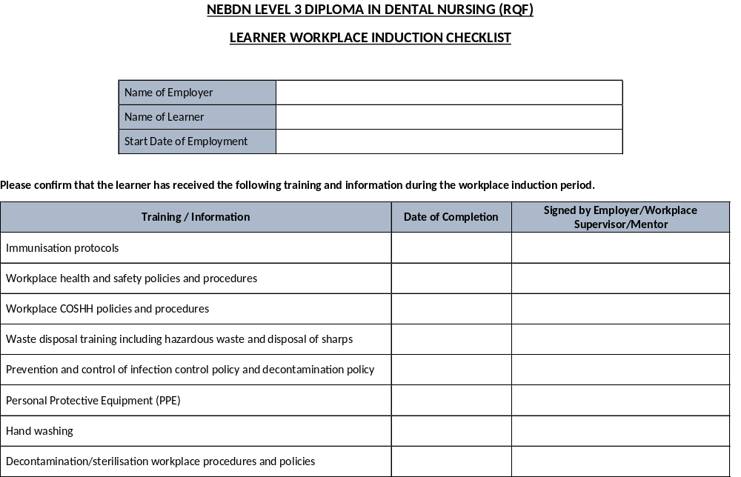

Sharps injury protocol
Reporting of injuries, accidents, hazards and risks, and records required (including RIDDOR)
Risk assessments
Duty of candour
Fire safety and evacuation procedure
Radiation protection policy and procedures including IR(ME)R & Local Rules
Patient care
Medical emergencies including protocol for and location of emergency drugs, equipment, and defibrillator.
Basic Life Support training
Equality, diversity, and inclusion policy
Professionalism and GDC Standards for the Dental Team
Confidentiality/data protection
Patient consent
Complaints Policy
Safeguarding and Prevent
Governance and Quality Assurance systems
Student identification

I confirm that the learner has an allocated workplace GDC Supervising Registrant (mentor)
The GDC Supervising Registrant (mentor) will be …………………………………………..
GDC Number …………………………………………………….

All of the above listed activities and training have been completed during the workplace induction. I confirm that records of training completed during the induction process have been maintained and can be presented if requested and are available for external audit.
The above-named learner is ready to provide chairside support during general dental procedures.

Signed by Employer/Workplace GDC Supervising Registrant | GDC Number: | Date:
Signed by Learner |  | Date:
Centre Signature | Position: | Date:

Employer and GDC Supervising Registrant Declaration
The GDC has reviewed the employing, supervising, and training guidance based on the GDC Standards for the Dental Team. The GDC States.
‘Before the trainee dental nurse undertakes any duties in the practice they must receive a formal structured induction, including training regarding patient safety and confidentiality; infection control; the protection of vulnerable children and adults; and how to deal with medical emergencies.’

‘The trainee dental nurse must not undertake exposure prone procedures until they have the appropriate vaccinations (if applicable) as required to practise. Please refer to the relevant health protection body in your country for further information.’

‘A named GDC supervising registrant must take full responsibility for providing direct supervision of the individual trainee. However, according to the ability and progress of the trainee, supervision may be delegated (if appropriate) to other GDC registrants.’

‘The named supervising registrant will continue to be accountable overall for the trainee.’
‘The employer must ensure that the individual trainee keeps a logbook of training they receive (including induction), which is regularly signed off by the designated supervisor.’

Failure to comply with this means ‘GDC registrants who employ, manage and/or supervise students/trainees risk fitness to practise proceedings if they fail to comply with this guidance or with the Standards for the dental team.’
(GDC Guidance for those employing, supervising or training students, trainees or learners)

As part of the agreement to support your trainee dental nurse during the training course and in compliance with the GDC and NEBDN Service and Monitoring Agreement, please read and sign below to agree to the following:
• The learner will keep a logbook of training they receive (including induction), which is regularly signed off by the designated Named GDC Supervising Registrant

• The Employer will ensure that the individual trainee keeps a logbook of training they receive (including induction), which is regularly signed off by the designated supervisor.

• Agrees for the provider to review the logbook of training as part of our monitoring systems as and when requested.

Employer:
Full Name:
GDC Number:
Signature:
Date:
GDC Supervising Registrant:
Full Name:
GDC Number:

Signature:

Date:

Appendix A:
Template: Waiting Room Patient Notice – Trainee Dental Nurse Declaration

Please use a notice such as this to make all patients aware that a trainee dental nurse is assisting. This allows for informed consent and transparency as required by the GDC Standards for the Dental Team 6:1.5.

Notice to Patients

At [Insert Practice Name], we support the training of future dental staff.

A trainee dental nurse may be present during your visit and treatment.

They are fully supervised by a qualified and GDC-registered staff member and in training on a recognised course leading to their qualification.

If you have any questions or concerns, please speak to your Dentist.

(An alternative template can be found in the ‘Policies for Students’ document – Appendix A - please click the link to the document in the Employers Information section)

APPLICATION CHECKLIST

Before submitting your application documentation, please check you have completed and included the following:

Application Form | ☐
One form of Photographic ID | ☐
Right To Work Documentation (if applicable) | ☐
Copy of English Qualification Certificate | ☐
Equal Opportunities Monitoring Form | ☐
Course Suitability Checklist | ☐
Service Monitoring Agreement | ☐
Copy of Workplace CQC Certificate | ☐
Learner Workplace Induction Checklist | ☐
Employer and GDC Supervising Registrant Declaration | ☐

